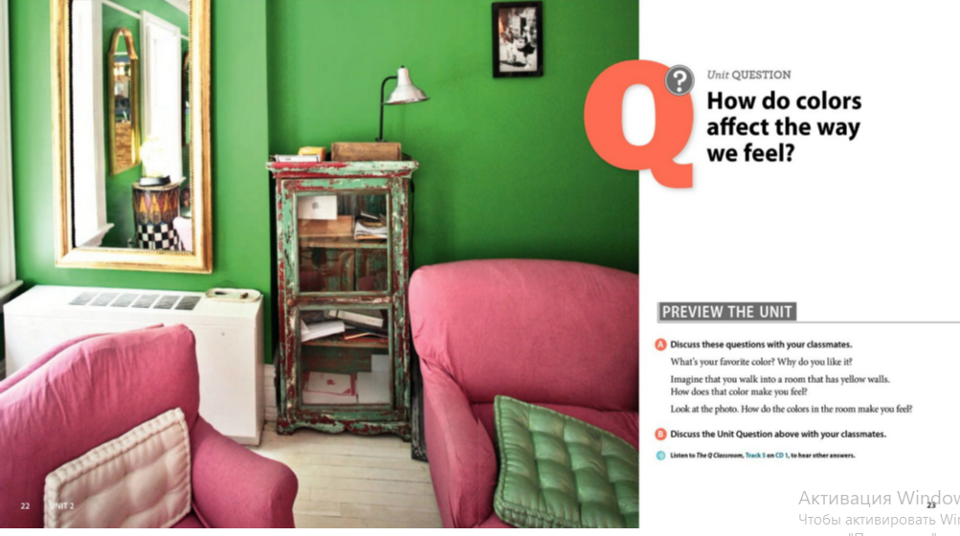

Speak about how colors affect people’s life

